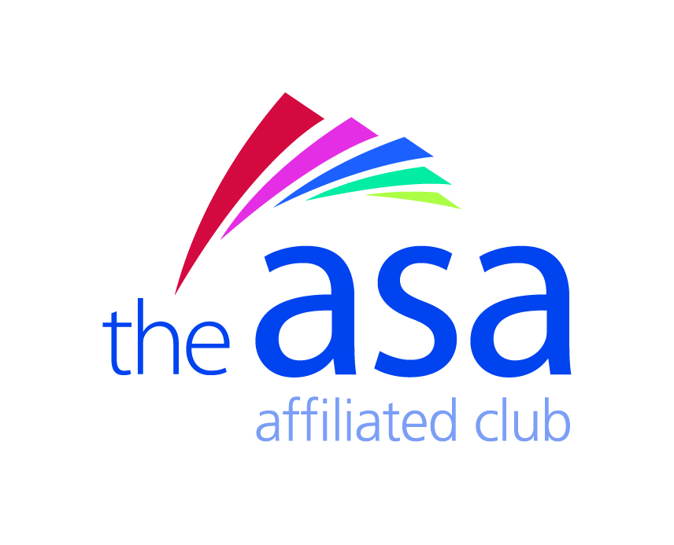
Mildenhall & District Swimming Club is a charity registered in England & Wales (1154407)
Election of Officers 2014/15
President | Wendy Read | wendyread1@me.com
Vice Presidents | Dave Robinson  Leon Russell  Steve Molyneux  Mel Molyneux  Gaz Jones | david@referee22.fsnet.co.uk  sallyleon4@aol.com  stevemolyneux616@btinternet.com  stevemolyneux616@btinternet.com  gazmeister@live.co.uk
Chairperson | Gaz Jones | gazmeister@live.co.uk
Vice Chairperson | Dave Robinson | david@referee22.fsnet.co.uk
Secretary  Minutes Secretary | Rob Garry  John Browne | rob@garry.me.uk  john.browne1@tesco.net
Treasurer | Brian Prince | brian@jkhltd.co.uk
Head Coach | Sally Russell | sallyleon4@aol.com
Assistant Coaches | Derek Marsh  Bert Girling | derekmarsh785@btinternet.com  bert@girling514.orangehome.co.uk
Team Managers | Lana Buckles  Sarah Carter | silana72@btinternet.com  laraloops@btopenworld.com
Away Gala Organisers | Lana Buckles  Sarah Carter | silana72@btinternet.com  laraloops@btopenworld.com
Home Gala Organiser | Virginia Jones | luvjones4@googlemail.com
Fixtures Secretary | Tracey Welbourn | traannwel22@talktalk.net
Membership Secretary | Rob Garry | rob@garry.me.uk
Press Secretary | Hollie Armstrong | holliearmstrong@hotmail.co.uk
Masters Co-ordinator | Rob Garry | rob@garry.me.uk
Badge Secretary | Benita Garry | benita@garry.me.uk
Child Welfare Officer | Jeannie Morley | jeannie.morley@live.com
National Registration Officers | John Browne  Rob Garry | john.browne1@tesco.net  rob@garry.me.uk
Competitions Co-ordinator | Linda Lewis | linda.lewis-dimmock@live.co.uk
Suffolk ASA Delegate | Gaz Jones | gazmeister@live.co.uk
School Liaison Officer | Hollie Armstrong | holliearmstrong@hotmail.co.uk
Club Kit Organisers | Rob Garry  Benita Garry | rob@garry.me.uk  benita@garry.me.uk
Club Championship Secretary | Wendy Read | wendyread1@me.com
Record Secretary | Rob Garry | rob@garry.me.uk
Swim 21 Co-ordinator | Wendy Read | wendyread1@me.com
Club Captain Organisers | Team Managers / Coaches | As above
Volunteer Coordinator | Hollie Armstrong | holliearmstrong@hotmail.co.uk
Disability Liaison Officer | Benita Garry | benita@garry.me.uk
Committee Member | Sarah Kerins | crackersbrackers@aol.com

